# 1. Online Courier Services Java Project

Online Courier systems have improvised the shopping experience to an exponential level. Be it your lunch or your favorite electronic gadget, you can place an order for it online, and the product will be delivered in no time.

This kind of application is used by any product and service-based company like Flipkart, Amazon, Uber, and much more. Experience in designing, developing, deploying such an application could make you stand out and make it easy for you to get into your dream company.

The Online Courier Service project deals with the 'Courier Service management System.' The system will be used for day-to-day activities.

* Product
* Buy a Product
* To return a product
* Payment Window
* company details
* hub rates
* Delivery Details
* Non-delivery Details
* Reviews

The flow of Online Courier Services.

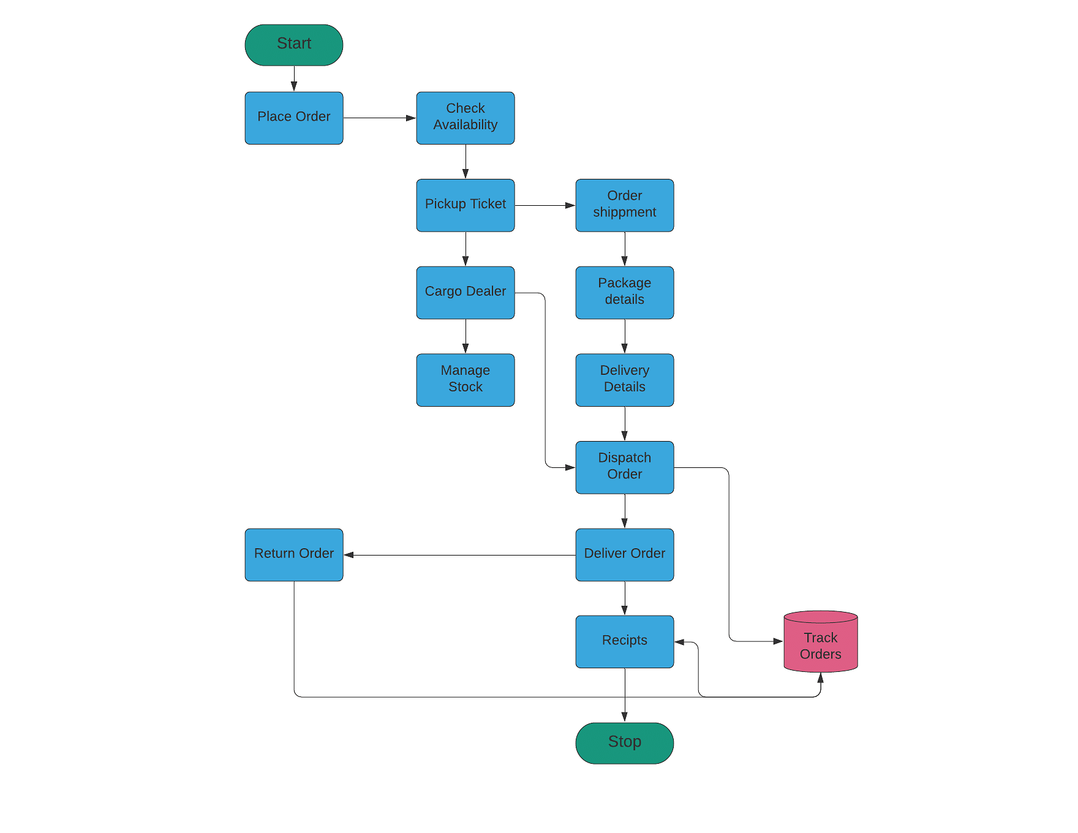

# 2. Online Voting System

Despite providing updates and awareness ads on social media, television, and even newspapers, our system could not encourage many to cast a vote.

This issue is only caused by not having an alternative for the current voting practices as they are proven to be time-consuming, and the most tedious job is to wait in a queue to cast your vote. The issue can be changed by developing an online voting system.

The online voting system project is designed for the Government to help the public cast their votes in the simplest way possible.

The project would include two stages.

Admin

* Manage Election Candidates
* Manage Voting Candidates
* Profiles and Passwords
* Election Results

User/Voter

* Registration
* Login and Logout
* Profile and Password
* Choose a candidate to vote
* Cast Vote

The flow of Online Voting System.

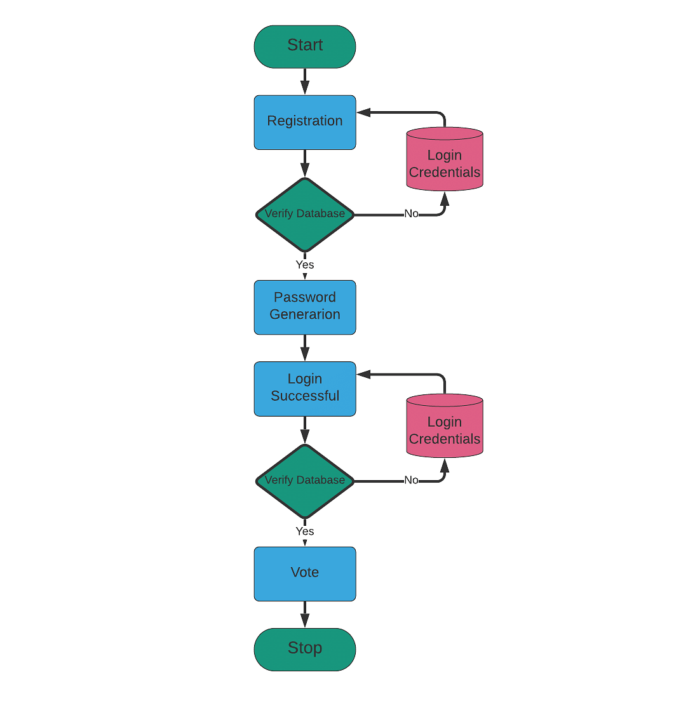

# 3. E-HealthCare Management

At the time of 2020's Pandemic, everyone needed a virtual doctor who could attend to them via a smart device and assist the patient with a medical prescription online. The application can keep both the doctor and the patient socially distant and safe.

This application would be of great help for issues like the common cold, fever, and other similar health problems that did not need a physical presence of either a patient or the doctor. A few such applications are in the development stage.

E-Health Care Management System is a web-based project. The main objective of this project is to provide perfect management of data related to staff and patients in hospitals

* Doctor Registration
* Patient Registration
* Web UI
* Hospital Registration
* Database to keep track of beds and patients

The flow of E-HealthCare Management

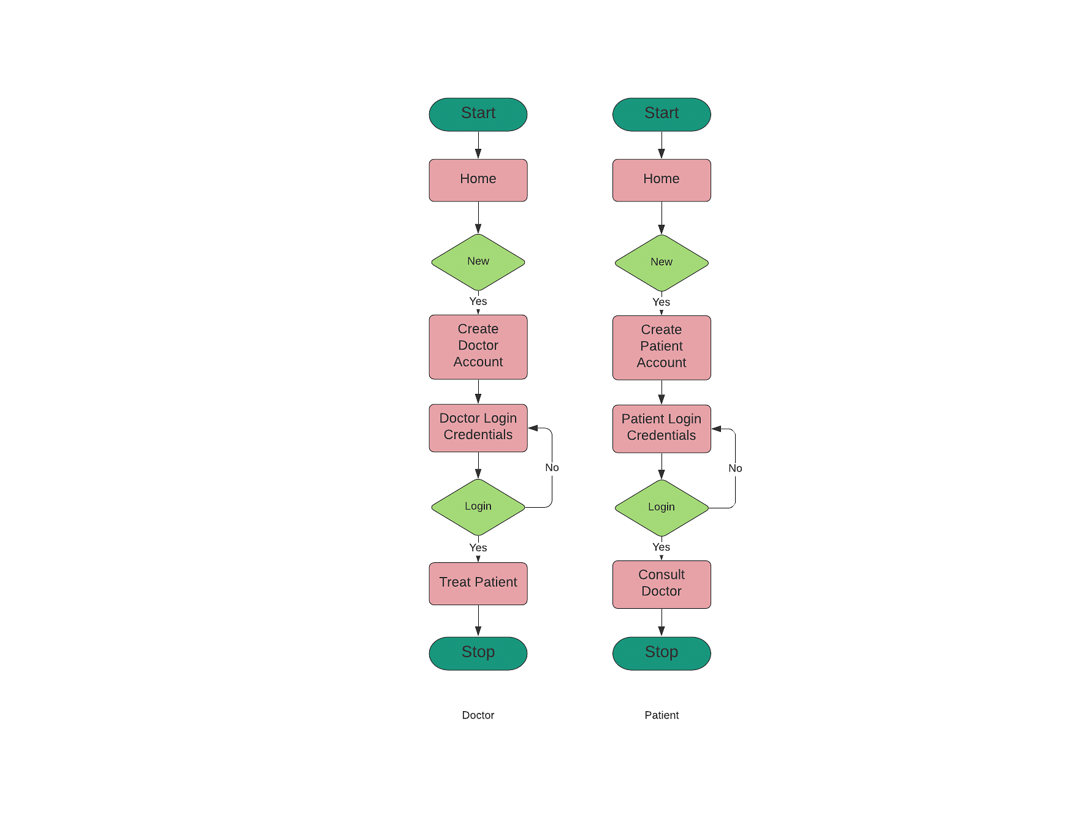

# 4. Online Banking

Online Banking has changed the way banks usually function. It brought most of the time-consuming procedures like money transfer, RTGS, NEFT to account holders' fingertips. Most of the national and multinational banks use internet banking these days.

Online Banking System is a model - Banking Site. This site helps customers to perform bank transactions through a phone or laptop. The project would be performing the following operations.

* Home page of the Online Banking site
* Creation of the new accounts
* Login, Logout
* Manage Profile and Password
* View the balance of the account
* Deposit the amount
* Withdraw amount
* Transfer the amount
* Close account

The flow of Online Banking

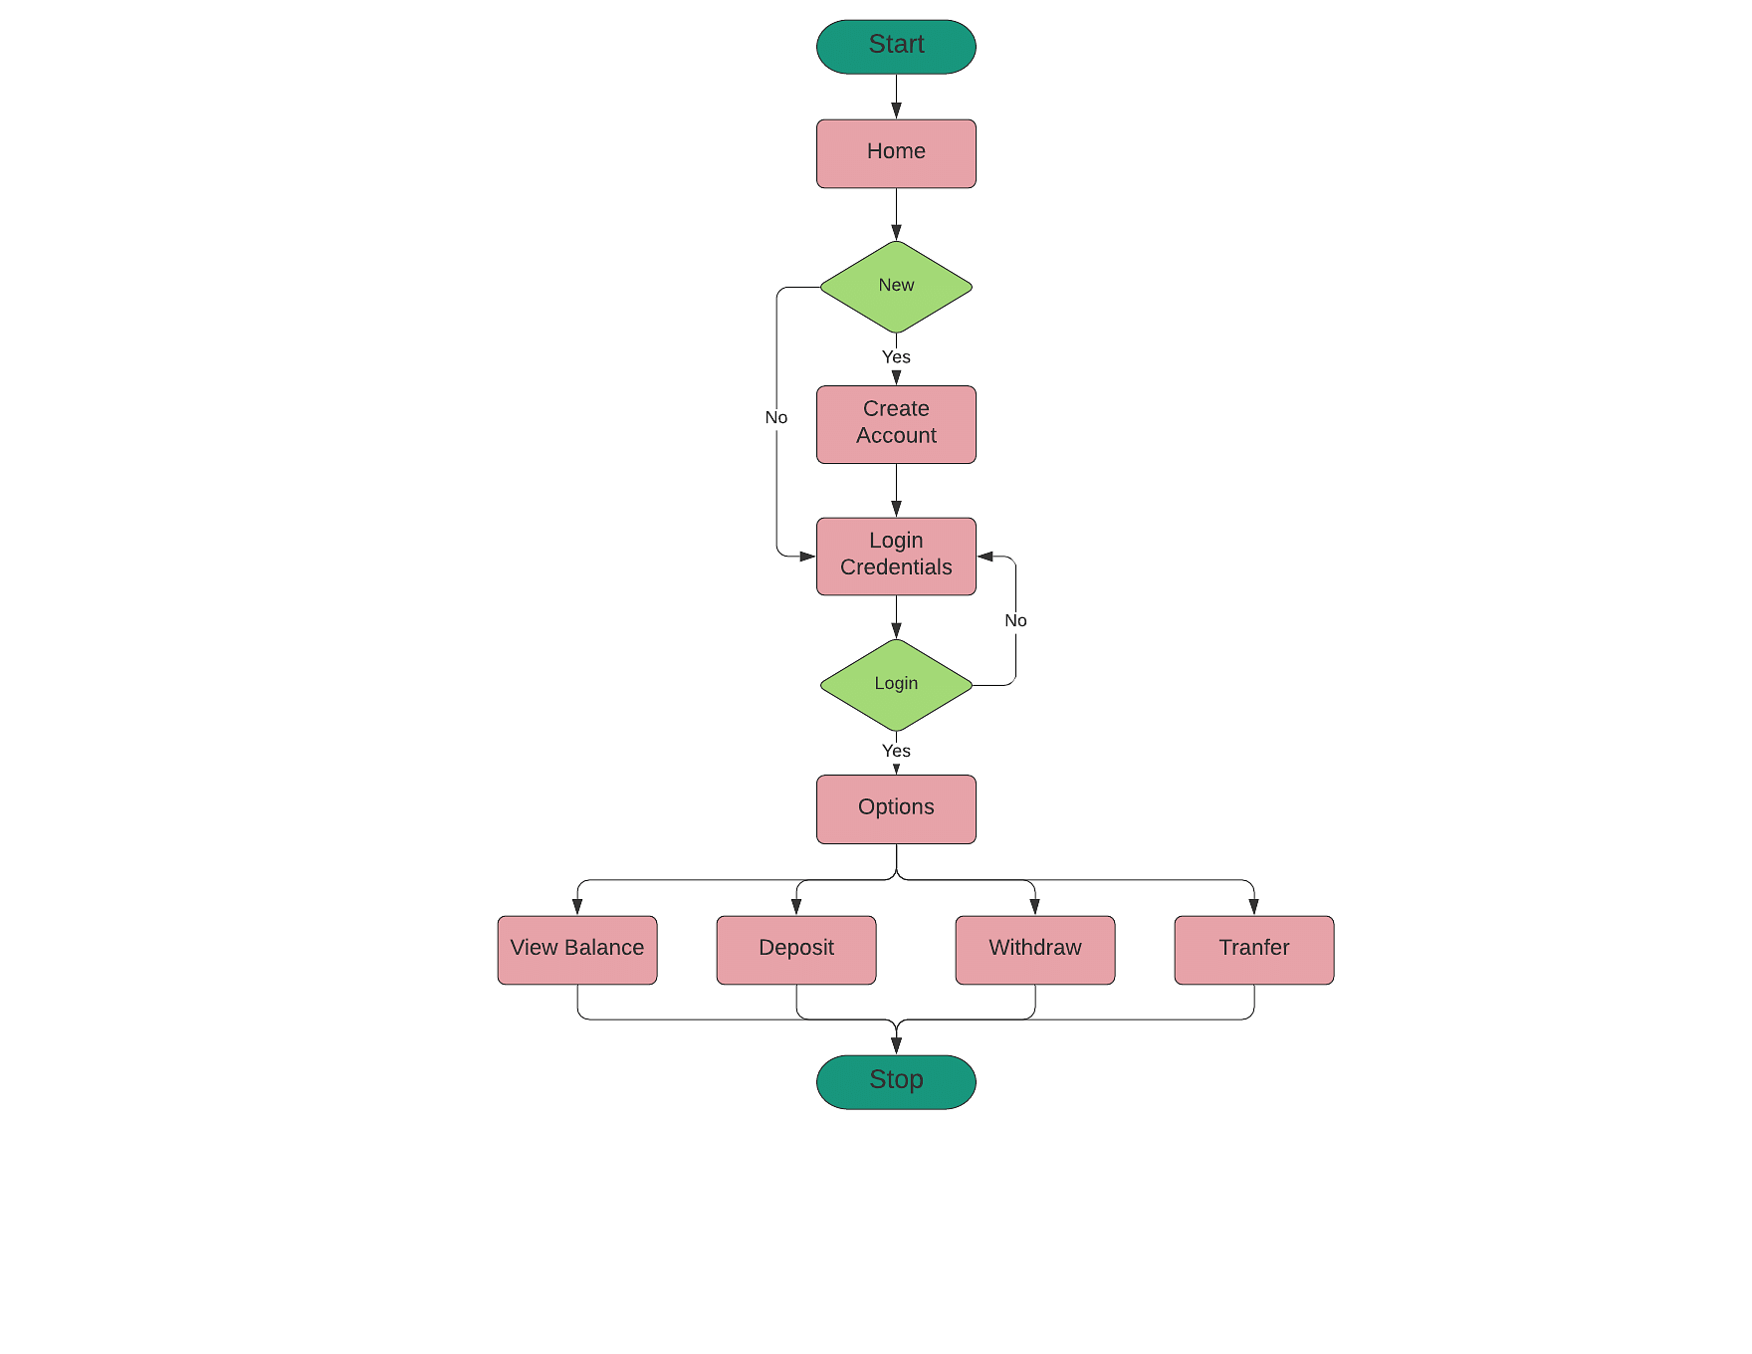

# 5. Online Examination

Most schools, colleges, universities, and even Government and Private offices have switched from traditional paper-based examinations to online examinations. Due to the wide-spread applications, this project might help you learn more about a wide variety of skills.

The project should be capable of the following functionalities.

* Login
* Update Profile and Password
* Selecting answers for MCQs
* Writing Answers to questions
* Closing session and Logout

The flow of Online Examination Project

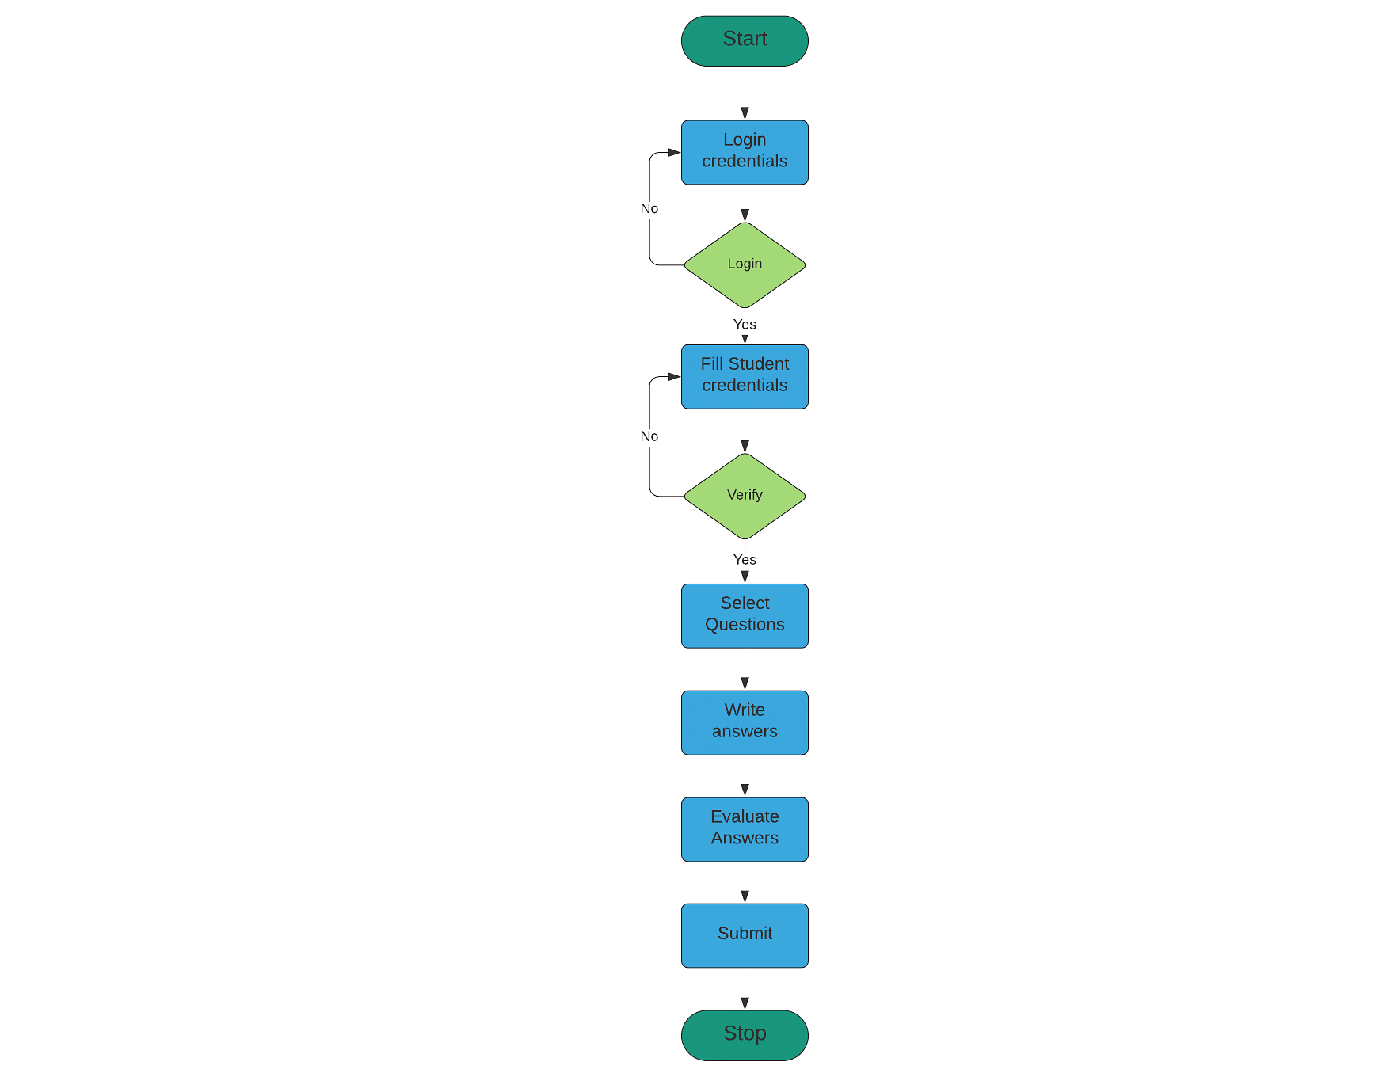

# 6. Smart-city Project

Internet connectivity is one of the necessities of every human being these days. The same applies especially to all the cities. Metropolitan cities have seen a dramatic increase in internet users, and the facilities have proven to be a lot useful.

Smart-City provides services like Hotel booking, Ticket booking, Transport facility providing, business-related information, marketing details, city news, shopping details.

The Smart-city project should be capable of the following functionalities.

* Login
* Update Profile and Password
* Search for options
* Select option
* Booking
* Payment window
* confirmation

# 7. Bug Tracking System

No one can avoid bugs in the software development stages. Creating a tracking system capable of assisting the software developer in tracking, managing, and eliminating bugs would be a great idea.

The Bug Tracking System in JAVA is used by software companies. The project is to manage the errors, or that occur during the software development phase.

The project should be capable of the following.

* Managing bugs in development
* facilitate bug search
* Provide bug history and solution
* Store older bug reports
* Evaluating the works of employees.
* Auto-update to the latest version

The flow of the Bug Tracking System

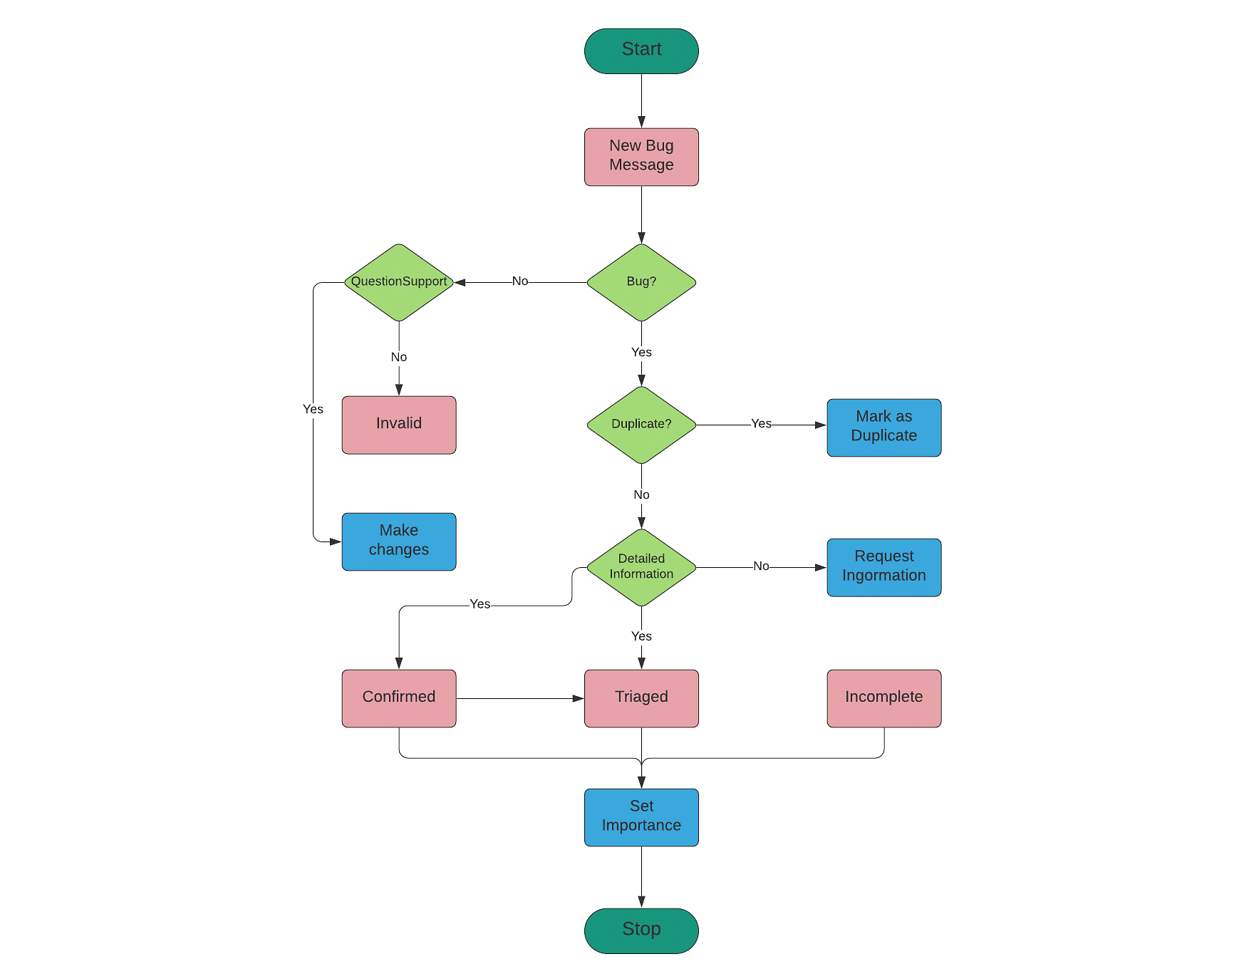

# 8. Facial Recognition

Face Recognition is one of the most popular tools used in various domains, like phones, Law enforcement departments, etc. Working upon one such type of project will help you improve your skills by using multiple libraries, for example, OpenCV.

Face Recognition with OpenCV is an open-source computer vision library with tons of modules like object detection, Face Recognition, and augmented reality.

The project should be capable of the following.

* Managing user's faces
* Facilitate face identification
* Easy Login and Logout
* Store Face IDs
* Identify suspect with just images
* Enhanced way to find Cybercriminals

The flow of Facial Recognition Project

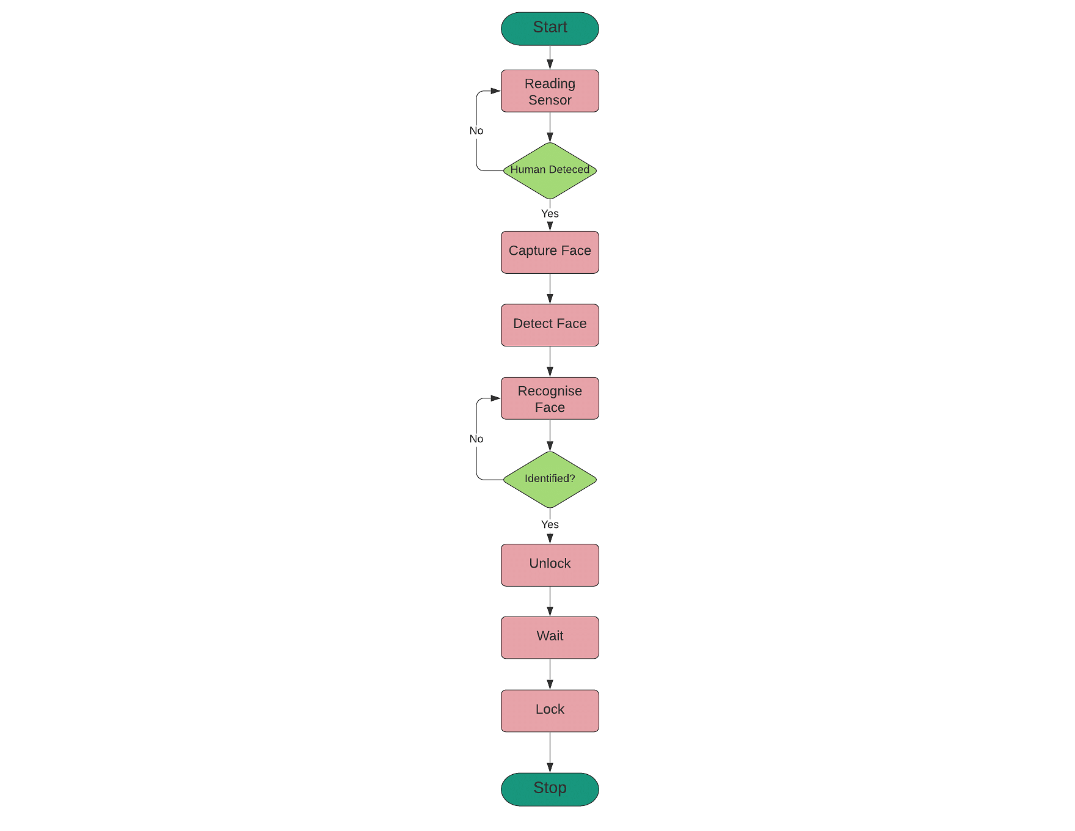

# 9. Vehicle Recognition

Similar to Face Recognition, the Java Vehicle Recognition also has a wide range of applications in real-time. The Vehicle Recognition application is used to identify vehicles by reading the license plate on them.

A [machine learning algorithm](https://www.simplilearn.com/10-algorithms-machine-learning-engineers-need-to-know-article) captures the image and reads the alphanumeric values on it, and fetches the vehicle's details.

JavaANPR is a number plate recognition software that implements algorithmic and mathematical principles from [artificial intelligence](https://www.simplilearn.com/tutorials/artificial-intelligence-tutorial/what-is-artificial-intelligence), machine vision, and neural networks.

The project should be capable of the following.

* Capture the image
* Image Preprocessing
* Licence character set segmentation
* Feature Extraction
* Training Neural network
* Evaluation
* Result

The flow of Vehicle Recognition Project

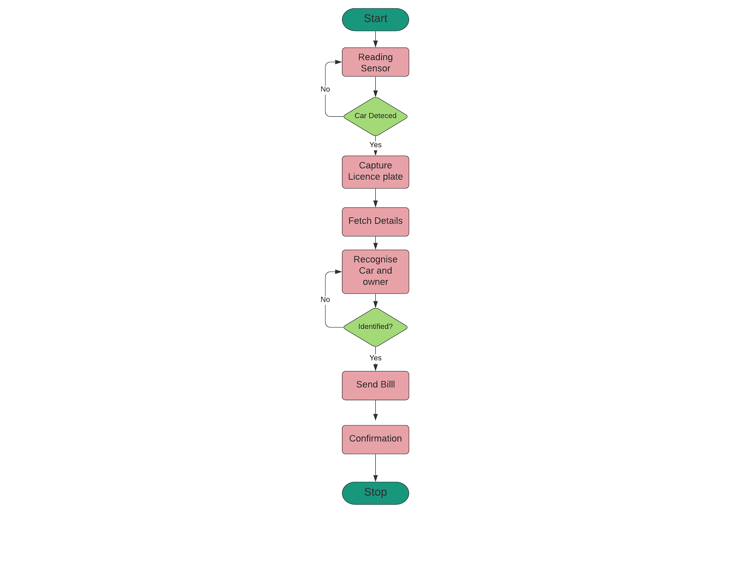

# 10. Speech Recognition

The exponential rise in [Artificial Intelligence and Machine learning](https://www.simplilearn.com/ten-years-of-artificial-intelligence-and-machine-learning-article) paved the way for [Speech Recognition.](https://www.simplilearn.com/tutorials/python-tutorial/speech-recognition-in-python) It is widely used for many purposes, like Alexa, Cortana, Google translate, security, and much more.

In Java, the Speech recognizer covers audio to text. java.speech.recognition package defines the Recognizer interface to support speech recognition plus a set of supporting classes and interfaces.

The project should be capable of the following.

* Create a Speech Recognizer
* Allocate Resources
* Load and Enable Grammar
* Attach Result listener
* Commit Changes
* Process Results

The flow of Facial Recognition Project

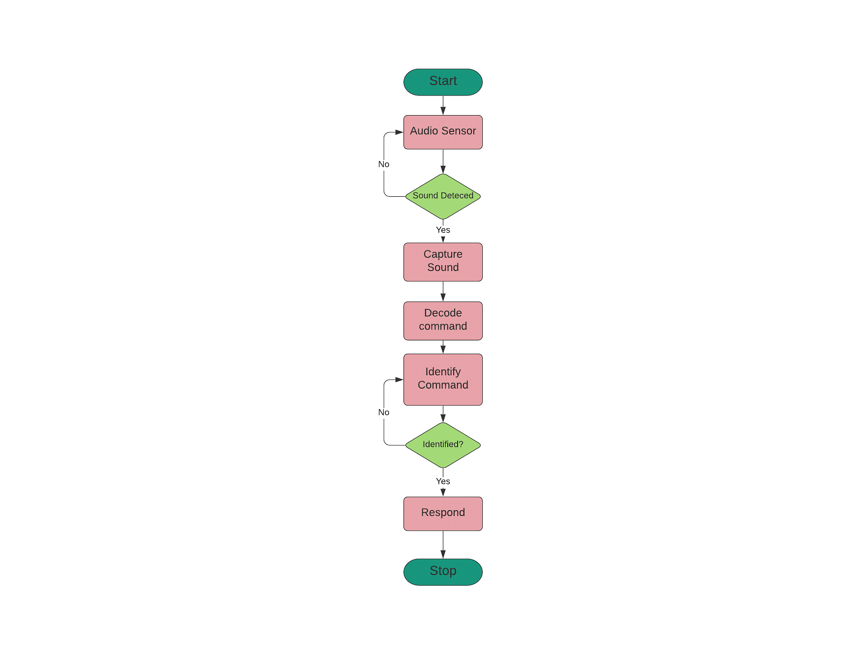

# 11. Airline Reservation System

An Airline reservation system is considered to be one of the great ideas to develop using Java programming language. It is a web application that has dynamic data and will be accessed by millions of users at a single time. So the backend development must be taken care of by the developers. The database needs to be updated regularly with time. It is an online platform that enables customers to book flights. Here are some of the main features of an airline reservation system.

1. Booking and cancellation of tickets
2. Transaction management
3. Offering a quick response to the customers and so on.

# 12. Data Visualization Software

Nowadays, many people use [data visualization](https://www.simplilearn.com/best-data-visualization-examples-and-how-they-work-article) software to draw insights from customer data. In the early 2000s, most of these data visualization software tools were developed using Java as the main component. It is widely used by the Data Science and Data Analytics people.

# 13. Electricity Billing System

The Electricity billing systems project is considered to be an alternative or a replacement to the conventional electricity billing system. The main objective is to digitize all the details of the electricity bill details, meter number, and units consumed. It enables the customers to calculate the electricity bill efficiently and in a simpler way

# 14. Email Client Software

The Email client software is intended to receive and send emails. It follows some of the standard concepts in computer science such as computer networking and other networking protocols like POP3 and SMTP. On the collector side, the mail server receives all the incoming mail and sorts them out in order. The entire transaction occurs by directly connecting to the mail server through the program, which makes it much safer than the existing email client software.

# 15. Library Management System

A library management system is much needed for every academic institution. Nowadays it is becoming harder to have systematic arrangements of the book in libraries, hence there is a need for a library management system where details of each and every book taken and returned by the student is noted down in the software, and can be accessed when needed.

# 16. Network Packet Sniffer

A network packet sniffer is a piece of software that analyses packets and is used to track network traffic. It is a Java web application that enables web-based network packet monitoring as they move across the system network. This packet sniffer, which was created as a desktop tool, enables web-based monitoring of network packets as they go across the system network.

# 17. Online Medical Management System

There is another Java project that helps in establishing direct contact between patients and doctors. By using this program, patients can make online appointments with their favorite doctors, and doctors can see the patient's medical information, lab results, etc., and provide healthcare advice as well as e-prescriptions. Users can search for and connect with blood and eye donors using the app. This is one of the best Java project suggestions available right now.

# 18. Online Survey System

The fundamental goal of developing this online survey system is to survey individuals online about various topics. The objective of this task is to build a Java-based system for conducting online surveys. The aim of the project is to provide an online platform with the ability to effectively gather survey respondents' opinions online. This software may start online polls and notify users via email. This application allows any company, regardless of industry, to conduct online surveys with their target audiences to gather the data they require.

# 19. RSS Feed Reader

The RSS feed reader program aims to decrease the time it takes for new content to show on the reader/aggregator once it has been published online. It makes it possible to swiftly extract the most recent information that has been published on a website and make it available to visitors for reading on the aggregator. All RSS feeds have improved content monitoring policies included in the RSS feed reader management platform.

# 20. Stock Management System

Typically, managing stocks with pen and paper is not so easy. This Java-based web application was developed to manage stocks for companies and organizations as well as the buying and selling of their goods. This system's overall goal is to control the acquisition of items and stock for an association or organization. Different modules and features for adding, changing, viewing, and deleting goods from the system database are part of the stock management system.

# 21. Supply Chain Management System

The management of businesses linked by a network is referred to as supply chain management. It includes a variety of management procedures such as raw material handling, storage, movement, inventory, and transporting of finished goods from the source to their final destination.

This project aims to improve supply chain management by closely monitoring dealers and clients and tracking products as they move through the supply chain. A company can use this application to directly communicate with its clients, obtain product requirements, manufacture the product to meet those requirements, and finally ship it to the client.

# 22. Virtual private network

VPN is currently one of the most famous Java projects. This virtual private network's (VPN) objective is to extend a secure network all over the public domain. A VPN is set up by establishing a point-to-point virtual connection through traffic encryption, dedicated connections, or virtual tunneling protocols.

# 23. Word Count Tools in Java

It is among the most widely used tools in daily life by many content writing professionals. The programmer creates an interface for customers to document their content and then calculate the total number of words in it. In order to process the content, the programmer plans it out and saves it in a file. The content is then processed using the String class to determine the words. The programmer creates various options to make the project more creative and interesting. You can also use the Java formatting APIs to format the client-supplied content.

# 24. Create a Consumer Relationship Management System

This advanced Java project necessitates refined knowledge of Java database connectivity, MySQL, HTTP, and the JSpring framework. You will create a management system for the web platform that will allow community managers to revise and access consumer data in order to improve customer satisfaction. This project makes use of the Spring framework and provides source code for Java.

# 25. bFit Cognitive and Memory Testing Game

This project is indeed an online brain strength training game that tests your memory and cognitive abilities. You would then start creating this application by putting up the user interface, implementing game logic, making a splash screen, creating a game guide, and arranging the game screens. You'll also need to create an APK for the app's release.

# 26. Internet Service Provider Automation System

This ISP automation system provides an automatic troubleshooting system and shows the errors to the clients. You will also be tasked with connecting the communication systems between the server and the ISP. It is made up of four automation modules: user login, hardware and software modules, service module, and connection module. To build this system, you will need to use Java technology and J2EE.

# 27. Airline reservation system



One of the best ideas to start experimenting hands-on with Java projects for students is working on an Airline reservation system. The airline reservations system is a web application that aims to automate the ticket booking system of airlines. The proposed airline reservation system is a web-based Java project. It is an online platform that customers can use to book their flight tickets and check their flight details. It is a comprehensive passenger processing system that includes inventory, fares, e-ticket operations, and online transactions. The main features of the airline reservation system are:

* Reservation and cancellation of the airline tickets.
* Automation of airline system functions.
* Perform transaction management and routing functions.
* Offer quick responses to customers.
* Maintain passenger records and report on the daily business transactions.

This integrated airline reservation management application features an open architecture that encourages the addition of new systems and functionalities. This means that the app can be tweaked to keep up with the dynamic needs of the airline business. If you are looking for cool java projects to add to your resume, this is the one. Actually, this is one of the best topics in Java for solidifying your resume.

The VRS software suite incorporates four key modules, namely, user registration, login, reservation, and cancellation. This is one of the important java projects for beginners. The app allows for all communications to take place through a TCP/IP network protocol, thereby facilitating the usage of intranet and internet communications globally. The airline reservation system has many modules related to the application’s two major actors (Admin and Customer).

# 28. Course management system

This is an excellent Java project for beginners. As the name suggests, this course management system is an online management software application designed for educational institutions. A course management system Java projects for resume is a collection of technologies and topics in java that allow the instructor to produce online course content and publish it on the web. You need not have in-depth knowledge of HTML or other programming languages. The primary goal of the project is to facilitate seamless interaction between students and instructors in schools, colleges, and universities concerning the submission of projects, assignments, and thesis and receiving feedback from instructors. This project has three interlinked modules:

* **Administrator module –** This module is designed exclusively for managing administrative functions like creating accounts for students and instructors, creating the curriculum, coding the subjects, managing the employees, payroll, and so on. Basically, this module lays the groundwork for the other two modules.
* **Students module –** This module is designed for the usage of students. They can log in to their accounts to view their coursework, submit their projects, get feedback from instructors, etc.
* **Instructor module –** This module is for the instructors who can log in to their accounts and check the projects submitted by the students, communicate with the students, and offer guidance to them.

As we mentioned earlier, this project aims to promote the sharing of information between qualified instructors and students via the Internet.

# 29. Electricity billing system

This project is a modern version of the traditional electricity billing system. These Java projects for resume aims at serving the department of electricity by computerizing the billing system. The main focus of this Java project is to computerize the electricity billing system to make it more seamless, accessible, and efficient. It focuses on the calculation of units consumed during the specified time and the money to be paid to electricity offices. The software calculates the units consumed within a specified time duration and accordingly calculates the amount of money to be paid for those units. This is one of the excellent Java project ideas for beginners. The following features make the electricity billing system more service-oriented and straightforward:

* It features a high-performance speed along with accuracy.
* It allows for seamless data sharing between the electricity office and customers.
* It is protected by high-security measures and controls.
* It includes the necessary provisions for debugging.

Unlike the conventional billing system, this computerized software does not require a large number of human employees to handle and manage the process of bill generation. Once it is installed on the system, it will automatically calculate the units consumed and the bills from time to time and also provide the meter readings to each customer. You can continue to add new features in the system as and when user requirements change.

**How to enhance electrical billing system:**

* **Web-Based Interface:** Allows user interaction via browsers.
* **User Input for Meter Readings:** Customers manually enter meter readings.
* **Real-World Applications:** Utilized by utility and property management companies.
* **Enhanced Communication:** Improves company-customer interactions.
* **Automation of Data Collection:** Directly collects data from meters.

# 30. Email client software

So, why not use your skills to develop an impressive java project based on an email system? This project is an email program designed for sending and receiving electronic mail. In the project, you will use the standard sockets and networking along with Java Mail API. The project is developed through Java APIs. The project will need standard sockets and other networking in addition to the Java mail APIs. There are two main protocols used in the project – SMTP and POP3. This is one of the java projects for beginners.

Usually, conventional email client software conducts electronic mailing through web browsers like Hotmail, Yahoo, Google, etc. Since these systems use HTTP port 80 to access all the emails, it is not precisely the best means to send sensitive or confidential messages. Hackers can easily hack into the software system and violate or misuse the data.

The project functions something like this – the ISP’s (Internet Service Provider) mail server handles the emails sent from an ISP. All the sent emails first come to the mail server, after which they are processed and forwarded to the collector’s destination where another mail server is located.

The mail server on the collector side receives the incoming emails and sorts them electronically in the inbox. Now, the recipient can use their email application to view the received emails. The entire transaction occurs by directly connecting to the mail server through the program, which makes it much safer than the existing email client software.

# 31. Library management system



This software project is implemented in Java using MS Access database design. It is designed for managing and maintaining libraries in any educational institution through an integrated computerized system. The library management software will allow librarians to operate more productively while handling the typical day-to-day tasks of a library.

In a traditional library management system, everything is done manually. All the library operations and records, including the number of books, genres of books, names of books, records of the students who’ve issued/returned books, etc., are all done via pen and paper. Naturally, this process requires a significant amount of time, effort, and even human resources. If you are looking for final-year java projects, this is perfect for you.

The proposed project seeks to solve all the challenges associated with the traditional library management system. Since it stores and manages all the library records in a computerized database, it eliminates the need for manual record-keeping. The software includes different modules, each of which handles and manages specific library operations. Mentioning Java projects can help your resume look much more interesting than others.

By using this software application, librarians and students need not search the entire library to find a book. They can enter the name and author of the book, and the system will display the list of all the possible books available for that search keyword/phrase. This is one of the best features of this library management software.

# 32. Online quiz management system

One of the best ideas to start experimenting you hands-on Java projects for students is working on online quiz management. This Java-based application proposes to create an online discussion platform that will consist of a wide range of questions on different topics, fields, and subjects. By creating a user-friendly environment of Bluebook implementation, this application is a resourceful tool for individuals who wish to practice mock quizzes and tests. Online quiz management system is one of the interesting java projects.

In this project, you will build a comprehensive online platform for managing both quiz competitions and the participants in the different teams. This application can be used by academic institutions and any organization willing to find suitable candidates through the process of quizzing.

The application permits multiple admins, each having their unique user id and password. While admins can create an “n” number of participating teams for a quiz, they can also set an “n” number of rounds for the quiz. All the participants will automatically receive the questions, and the teams will have to answer within an allotted time.

In case a team is unable to answer a question or gives the wrong answer, they’ll receive a negative marking. The teams having the lowest average score will be eliminated, and the remaining teams will continue to compete in the next level. This will continue until the winner is declared. The scores for each team will be automatically updated. And this is the perfect idea for your next Java project!

# 33. RSS feed reader

The goal of the RSS feed reader project is to minimize the delay between the publication of new content on the web and its appearance on the reader/aggregator. It allows the retrieval of the latest content posted on a website quickly on the aggregator, thus, making the content readily accessible to the users for reading. The RSS feed reader management system is equipped with improved content monitoring policies for all RSS feeds.

The existing aggregator management applications use the homogeneous Poisson model that relies on a specific data source (either a webpage or RSS feed). As a result, these applications cannot adapt if the data source changes. They do not even have well-designed monitoring policies. This project incorporates and implements new content monitoring strategies to overcome the drawbacks of the existing aggregator management applications. The new RSS feed reader leverages a non-homogeneous Poisson model and delays matrices.

This RSS feed reader management system investigates the techniques used by RSS aggregation services to monitor web content and to retrieve the data promptly using minimal resources, to enable readers to access the content without delay. The project focuses mainly on the server-based aggregation scenario.

**The proposed model has the following functional requirements:**

* It should be able to provide information from disparate data sources to all users.
* The system should be able to run efficiently using minimal system resources.
* The time delay must be minimized so that users can view the data quickly on their feed.
* The aggregated content should be converted into a document format compatible with browsers.
* The RSS content must be monitored at frequent intervals.

# 34. ATM simulation system

Among the most user-oriented Java mini projects for engineering students, an ATM simulator offers an easy and effective way to deposit and withdraw money and check account balance. It is based on the command-line user interface, where a switch case executes all transactions (withdrawal and deposit) and balance checks. Each operation is followed by an instant account update, helping customers keep track of their transactions.

The system comprises two aspects — admin mode and user mode. The admin side allows the bank’s staff to register a new account, update existing accounts, delete obsolete accounts, and view user account records. Whereas, the user mode allows customers to perform transactions to another account, withdraw money, print receipts, and check balance.

Key features of the ATM simulator system are as follows:

* 24*7 banking service
* Reduced human error
* Banks will receive notification about any impending maintenance of ATM
* Constant updation of bank records reduces backlogs in the system
* Enhanced security between bank servers and customers
* Improved customer service

# 35. E-magazine

This is among the simplest Java mini projects. In this project, a platform is created mimicking an online magazine. In other words, an e-magazine offers the facilities and features of an online magazine, providing users with international and national news and articles categorized distinctly into separate sections.

With the advent of digitization, many publishers have shifted to the internet to provide digital versions of their printed magazines and journals. Some companies have entirely quit publishing printed versions to cut production costs and adopt more environment-friendly policies. Users of an e-magazine are generally classified into 2 categories — guests and paid users. Guests have access to only some features of the magazine, while paid users are given full access in exchange for a subscription fee.

This mini project in Java consists of 2 modules:

* **User Module-**Allows customers to log in, read the magazine, post comments, publish advertisements, and submit articles.
* **Editor** **Module-**Allows editors or the publisher to create new articles or content, edit articles, and see the magazine preview before publishing.

A few advantages of e-magazines are mentioned below:

* Saves paper, making way for a more environmentally aware society.
* Reduces cost significantly, thus increasing profit margin for publishers.

# 36. Currency converter application

If you are looking for Java mini projects for beginners, this is the perfect application for you to try your hand at. This simple project serves the purpose of converting different currency denominations.

Ajax is used to build this simple calculator-based application, and it offers a web-based interface. This project is equipped with a regular updation feature that enables it to keep up with the changing exchange rates. The app contains two fields, both denoting some currency. The user has to select the currency they want to convert and the one they want to convert into and then enter their preferred amount.

The app is extensively used in finance-related fields, businesses, and stock markets where currency exchange and transfer are done regularly.

# 37. Data visualization software

Data visualization is a crucial element in the modern industry driven by Data Science, Business Intelligence, and Business Analytics. It refers to the visual representation of data, either in a graphical or pictorial format. This is an important java project for beginners. This data visualization project is all about providing an overview of the design and implementation techniques in data visualization. The objectives of this project are:

* To deliver precise and effective communication of the insights hidden in the data through appropriate graphical or pictorial representations.
* To offer relevant insights into complex datasets for conveying ideas effectively.
* To stimulate the viewer’s attention and engagement while communicating accurate information.
* To be functional as well as aesthetically pleasing.
* For clear and effective communication of information through graphical or pictorial means.
* To provide necessary insights into a complex set of data and information and convey ideas effectively.

This data visualization software displays the node connectivity in networking in the form of data visualization. You can use a mouse or a trackpad to locate it at different locations. The best part about the project is that you can enhance and tweak the software features and functions according to your requirements. Mentioning Java projects can help your resume look much more interesting than others.

# 38. Smart city project

The Smart City project is a web-based software application built to store all the essential details of a city. Cities and urban areas witness a massive wave of people coming from every corner in search of jobs, education, and even a better lifestyle. In the initial days after the move, people don’t know the main facilities, attractions, and services offered in the city. The smart city project seeks to address that by creating an integrated platform to store essential and related information to guide newcomers in a city.

The application will provide visitors, students, and job seekers information like hotels, renting facilities, transportation services, healthcare services, airline ticket booking, shopping landmarks, emergency helplines, and basically every information that one needs when in a new city. It is like a smart city guide for visitors.

Users can connect to the application via the Internet and browse all the smart city web pages to get the details they need. Users can see the entire map of a city along with the important landmarks. This will make their movement across the city much more comfortable. Mentioning java projects can help your resume look much more interesting than others.

**The smart city application has five modules:**

* **Administration module –** It is the central controller of the application. It uploads all the new information on the site and authenticates user profiles, and supervises the maintenance of the other four modules.
* **Tourism module –** As the name suggests, this module handles all the tourism-related operations in the city, such as hotels, restaurants, tourist attractions, ATMs, theatres, and so on. A user authenticated by the administration module becomes the primary user of this module.
* **Student module –** This module is designed specifically for helping students move around the city. It contains all the academia-related information for students, including the location of the best educational institutes, libraries, coaching centers, technical colleges, universities, colleges, etc.
* **Jobseekers module –** This module contains important information on the job opportunities available in the city. Users can access all kinds of job-related information across various industries. The main objective of this module is to help the city administration to combat unemployment problems in the city.
* **Business module –** This module focuses on offering business-related news, information, and opportunities in the city. Users can access information on trade and business centers and industries in the city.

# 39. Stock management system



This is one of the trending Java projects. This web-based Java application is designed to manage stocks for companies and organizations and also handle the sale and purchase of their products. The principle goal of this undertaking is to oversee stock for an organization or association and deal with the acquisition of items. The stock management system includes different modules and features for adding, editing, viewing, and deleting items in the system database.

Usually, the manual stock management method run with pen and paper is not only labor-intensive but also time-consuming. This approach lacks a proper data organization structure, which can give rise to many risks associated with data mismanagement. This stock management project is a more efficient and improved approach to stock data management. It is much more secure and reliable than the manual method.

In the application, the login page makes the system module. The Admin can use this module to log in to the system through a valid user ID and password. Once logged in, the Admin can control these features:

* Enter stock
* View stock
* Dispatch stock
* Move stock

The Admin can update and monitor all necessary information associated with stock management, including category, customer details, stock details, stock purchase, stock sales, stock entries, stock entries payments, stock sales payments, supplier details, etc. The application further includes other functions like printing payment receipts, viewing purchase reports and sales reports, and so on.

# 40. Supply chain management system

This is one of the interesting Java projects. Supply chain management refers to the management of businesses interconnected over a network. It includes a whole range of management procedures like handling, storage, and movement of raw materials, inventory, and transporting finished goods from the source to its final destination.

This project aims to smoothen the supply chain management process by closely monitoring the dealers and clients and continually tracking the products through the different points in the supply chain. Using this application, a company can directly communicate with its clients, obtain the product requirements, manufacture the product to fit those requirements, and finally ship it off to the client.

This project uses JSP, JDBC, and HTML for the front-end and MS Access as the back-end database. It is a web-based application that will automate the system of communication between the management or admin, dealers, and clients of the company. There are three modules in this application:

* **Admin module –** The Admin uses this module to check information on the manufactured products, newly launched products, and products that must be delivered to the clients.
* **Dealer module –** This module keeps track of all the essential information concerning the dealers, particularly the record of items. Dealers can generate and update the item list for a product using this module.
* **Client module –** The client uses this module to provide the necessary specifications of a product. The client feedback is processed through this module and forwarded to the Admin.

By using this application, the clients can directly convey their product requirements to the manufacturer, who then contacts multiple vendors to acquire the necessary resources for making the product. The dealers usually create a list of items as per the product information provided to them, after which the manufacturer selects the materials that best fit the specifications given by the client.

Then, the selected list of items is forwarded to the inventory department for processing, after which the manufacturing begins. Once the production is complete, the accounts department calculates the raw materials costs and manufacturing costs to generate the total bill. Finally, the product, along with the invoice, is shipped to the client. The client is free to offer feedback on the received product.

# 41. Virtual private network



VPN is one of the trending java projects. The goal of building this virtual private network (VPN) is to extend a private network across a public domain (for example, the Internet). A VPN is created by setting up a point-to-point virtual connection via traffic encryption, dedicated connections, or virtual tunneling protocols.

**There are three interconnected modules in this VPN project:**

* **Administration module –** This module monitors all the office operations and manages the staff details.
* **Marketing module –** This module handles everything related to the marketing operations of the software application.
* **Training module –** This module manages all the technical operations like software testing, networking, call center, and J2EE training.

**Confidentiality, authentication, and data integrity are the three core elements of this VPN security model. The other pivotal features of this application are:**

* It allows for the addition of new clients, a feature better known as “scalability.” This feature allows a company/organization to accommodate new clients in the network as it expands.
* It uses a remote backup server to prevent the system from failing due to sudden crashes. Since a VPN handles a large volume of files that are created every day, it is crucial to have a remote backup server to process all the requests coming from the client to the server and vice-versa.
* It uses a remote monitoring system to keep track of the activities of every client or individual connected to the VPN. This ensures that the privacy and security of the network remain intact.
* As is true of all VPNs, this VPN application, too, has the provision for certification in the system. When two or more LAN (Local Area Network) systems interact, certification is mandatory to protect the system’s security.
* It triggers and sends acknowledgment signals to notify clients of successful data transfer (whether or not the data has successfully reached the desired destination).

# 42. Customer relationship management system

The CRM system is designed with the aim to assist businesses in keeping digital records of all customer interactions. If you are considering Java projects for final year, this project is the best choice. It provides the source code for Java and uses the Spring framework. The project requires sound knowledge of MySQL, JSpring framework, Java database connectivity, and HTTP.

This application aims to help businesses improve customer satisfaction by providing access to past, present, and potential customer data and help maintain them efficiently. CRM systems operate by collecting customer data from various sources like the company’s website, live chats, social media, telephone, emails, etc.

This mini project in Java is an open-source desktop application consisting of 3 main roles — admin, user, and employee. The primary user is the admin, who can change product-related details like adding, deleting, and updating. They can also change the FAQs and keep track of user history, employee details, complaints, inquiries, etc.

Employees can access complaints, inquiries, and product lists and also keep profiles updated with information collected from emails, calls, and chats. This reduces the time to resolve customer issues, enhancing the overall customer experience.

Conversely, users can view product details, raise complaints, view FAQs, and make service/product-related inquiries.

Some advantages of the CRM system are:

* Build a robust and secure CRM application.
* Drive customer engagement
* Contains records of users, employees, complaints, resolutions, and more.
* Provide error-free application

# 43. Mobile tracking system

Of all the Java project topics, this one ranks among the top useful application ideas. Mobile phones are no longer used for luxury but have become a necessity in the modern world. With violent incidents becoming commonplace, safety concerns have increased manifold in the last couple of years. This is where Java mini projects like this come in handy.

As the name suggests, the mobile tracking system tracks the present location of a user’s phone. This web application is developed on MySQL database using PHP. It constantly updates the location of the chosen device every five seconds through a central tower. The system sends the server the mobile ID and location, along with the time the device was present at the location.

The system has to be installed in the chosen device, following which each device is assigned a unique ID. This ensures you can track the desired mobile phone from anywhere, anytime. This project aims to boost security and consists of two primary components: the web application (serves as the admin) and mobile tracking software installed on the phone to be tracked.

# Why Java?

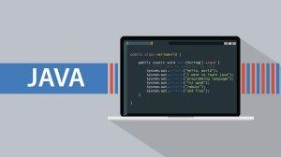

Although Java is a relatively new programming language (**it was launched in the early 1990s**), it has created a unique niche in the IT industry. Java is the driving force behind some of the largest organizations, including Airbnb, Uber, eBay, Pinterest, Groupon, Spotify, Intel, Symantec, TCS, Infosys, Wipro, Flipkart, and TripAdvisor, to name a few.

As an OOP language, Java has a modular structure, making solving complex problems significantly easier. Thus, programmers can write reusable codes with Java, enhancing the development process. Additionally, Java offers various features, such as polymorphism, abstraction, inheritance, and encapsulation, that further simplify the code-writing process. Easy to program and run, Java-based applications can be developed to operate on one computer as well as multiple client and server systems within a network.

**The five main reasons for Java’s popularity are:**

* **Platform independence –** Java runs on the WORA (Writing Once, Run Anywhere). A Java code is compiled into an intermediate format (a.k.a. bytecode), which is then executed in the JVM (Java Virtual Machine). So, any system running a JVM can execute Java code. Furthermore, JRE (Java Runtime Environment) is compatible with all three operating systems – Linux, macOS, and Windows.
* **Multi-threaded –** Java has inbuilt multithreading capabilities, which means that you can develop highly interactive and responsive apps with multiple concurrent threads of activity using Java.
* **Object-oriented –** Java is a purely object-oriented language. Inspired by C and C++, Java extends the functionality of these languages to become a pure object-oriented programming language. Abstraction, encapsulation, inheritance, and polymorphism are some of its core OOP features.
* **Secure –** When it comes to safety, Java incorporates a host of safety features into the runtime systems, including runtime checking and static type-checking at the time of compilation. With these features in place, it is pretty challenging to hack into a Java application from an external source.
* **Robust –** Java leverages a simple memory management model reinforced by automatic garbage collection. Since Java objects do not require external references, Java code is robust. Besides, it also encourages developers to adopt productive programming habits for developing secure and reliable applications. The more you experiment with different java projects, the more knowledge you gain.
* **Open source –**Java’s position as the second most trending programming language worldwide (IEEE Spectrum) in 2023 primarily rests on it being freely available for use; in other words, it is open source. This makes it ideal for developers and programmers of various competencies looking to build apps of their own. They can even access the latest versions of Oracle JDK and Open JDK free of charge through the Java Development Kit.
* **API rich –**Consisting of approximately 52 keywords, Java boasts a rich and extensive API (Application Programming Interface). Thus, making projects in Java is easy, with a multitude of methods available for use in any program directly. Developers can accomplish any task with Java API methods, whether handling output input, networking, processing XML, or connecting to databases.
* **Community backup –**Java’s robust and active community is among the many reasons for its continuing popularity. The Java Community, Stack Overflow, and Java in General are some of the top communities where developers and beginners alike can find assistance when faced with a problem. If you are developing core Java projects or seeking project ideas for Java, you can find extensive and reliable support on these websites from expert developers.
* **Documentation support –**Another factor contributing to Java’s immense popularity is its detailed documentation feature. Javadoc, a well-documented guide, provides solutions to developers who face problems while coding any application or program.
* **Development tools –**In addition to frameworks, integrated development environments (IDE), and profilers, Java has an arsenal of various automation, debugging, and editing tools. Java has tools for every type of development project along with various stages of development. Different projects in Java require the use of different tools. These include Maven for building applications, Jenkins for integration and delivery, JIRA for bug tracking and planning, and Splunk for monitoring, to name a few.
* **User-friendly –**Java offers an easy learning curve with its simple English syntax and use of minimum special characters. This makes it easy for beginners and professionals to master this language. Basic knowledge of programming languages like C and C++ is all that is needed to learn Java and build projects using Java later. Resources are readily available online on various websites, mostly for free.